Ahram Kim

Isaac Howard

CS 498

January 22, 2018

Seminar 1 (01.19.18)

We were talking about the test in the first seminar. In computer science, testing is providing information, so people can make decisions by using observation and operations. According to the Wikipedia.com, software testing is an investigation conducted to provide stakeholders with information about the quality of the software product or service under test. It involves the execution of software component or system component to evaluate one or more properties of interest. Quality is meaning the value to someone, who matters, at some time, in some context, and context is meaning doing the best we can with what we get. There are ways to view Testing which is the test automation pyramid: Manual Test (from the top of pyramid)– GUI Test – Acceptance Test(API later) – Unit Test/ Component Tests.

And I got some information about the Agile Testing Quadrants which is highly effective tool for testing. The quadrants represent the many different purposes for different types of testing. According to the searchsoftwarequality.techtarget.com, left-hand quadrants make the team know what code to write. Right-hand side make the team learn more about the code they’re written, and this learning translates into new user stories and tests that feed back to the left-hand quadrants. Using the quadrants make the team make sure they have all the people and resources they need to accomplish it.

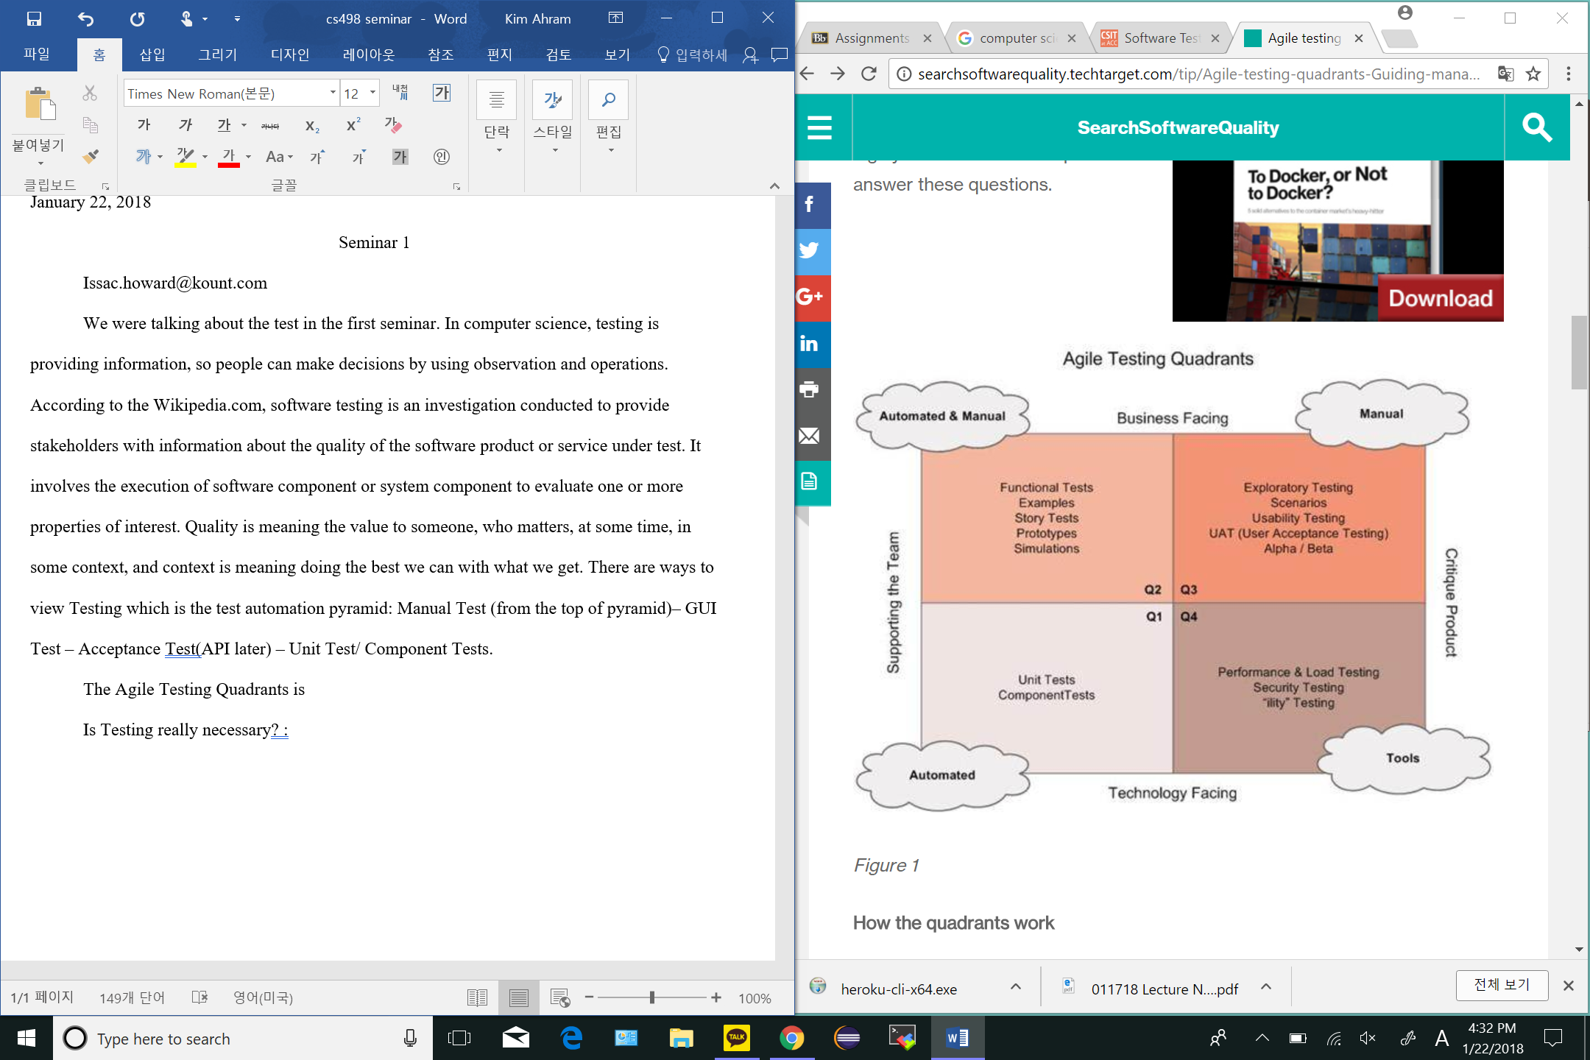

*Figure 1Agile Testing Quadrant (http://searchsoftwarequality.techtarget.com/tip/Agile-testing-quadrants-Guiding-managers-and-teams-in-test-strategies)*